**Detailed Business Specific Requirements:-**

**Theme**: Existing IT system for internal agencies of MoJS

**Applications**: WIMS expansion-WRIS

**Use Cases:-** Drought Affected Areas (2002)-**WRIS-SSA-08**

**Other linked Use Case :-** Drought Early Warning System* (DA-UC-01), Drought susceptibility map (DA-UC-02), Drought indicators (DA-UC-03), Drought outlook maps (DA-UC-04), Drought impact (DA-UC-05),Proactive management of Drought (DA-UC-06), Responses to Drought (DA-UC-07), Drought monitoring (DA-UC-08), Drought index (DA-UC-09), Ground Water Drought Index (GWM-UC-18),Crop production (IM-UC-07), Crop insurance (CWM-UC-14), Crop insurance (CWM-UC-14), Soil health index (CWM-UC-15), Soil Moisture (WRIS-MIS-13), Crop Water Requirement (CWR) (CWM-UC-04), Reservoir Storage status (RM-UC-02), Rainfall (WRIS-MIS-11).

**Description**:-

A drought is defined as "a period of abnormally dry weather sufficiently prolonged for the lack of water to cause serious hydrologic imbalance in the affected area.” –Glossary of Meteorology (1938). The occurrence of drought is

Cropping choices and agronomic practices, soil types, drainage and ground water profiles, to name a few. However rainfall deficiency and spatial and temporal distribution, duration and dry spells are acknowledged as the most important triggers for drought.

Drought Prone Areas Programme (DPAP) is the “earliest area development programme’ launched by the Central Government in 1873-74 to tackle the special problems faced by those iragile areas which are constantly affected by severe drought conditions. Based on the recommendations of Hanumantha Rao committee (1994) the programme has been under implementation on watershed basis since 1995. In 1977-78, Desert Development Programme (DDP) was launched for hot desert areas of Rajasthan, Gujarat, Haryana and cold desert areas of Jammu & Kashmir and Himachal Pradesh.

The Drought Prone Areas Programme wai operation in 627 blocks of 96 districts in 13 States during 1994-95. On the recommendation of the Hanumatha Rao Committee, 384 new blocks were brought into the purview of this programme and 64 were Transferred from DPAP To DDP. Consequently, Coverage of the programme was extended to 947 Blocks of 164 Districts in 13 States. With the reorganization of States, districts and blocks, at present the programme is under implementation in 972 Blocks of 182 Districts in 16 States namely Andhra Pradesh, Bihar, Chhattisgarh, Gujarat, Himachal Pradesh, Jammu & Kashmir, Jharkhand, Karnataka, Madhya Pradesh, Maharashtra, Orissa, Tamil Nadu, Rajasthan, Uttaranchal, Uttar Pradesh and West Bengal.

Similarly, in1989,Integrated Watershed Development Programme (IWDP) Was launched under the aegis of National Wasteland Development Board for development of wastelands onwatershed basis. A Common Guidelines for Watershed Development,2008 have been Issued and made effective from 1.4.2008. Since 26.2.2009, the three Watershed programmes of the Department Of Land Resources namely DPAP, DDP And IWDP have been consolidated as a comprehensive programme named ‘Integrated Watershed Management Programme (IWMP)*. This programme comes under Ministry of Rural Development.

**Reframe:**

A drought is characterized as "a period of abnormally dry weather sufficiently prolonged for the lack of water to cause serious hydrologic imbalance in the affected area" (Glossary of Meteorology, 1938). The occurrence of drought is influenced by various factors, including cropping choices, agronomic practices, soil types, drainage, and groundwater profiles. However, the most significant triggers for drought are recognized as rainfall deficiency, along with its spatial and temporal distribution, duration, and dry spells.

The Drought Prone Areas Programme (DPAP) is the earliest area development initiative launched by the Central Government in 1973-74 to address the unique challenges faced by regions that are frequently affected by severe drought. Following the recommendations of the Hanumantha Rao Committee in 1994, the program has been implemented on a watershed basis since 1995. In 1977-78, the Desert Development Programme (DDP) was introduced to support hot desert regions in states such as Rajasthan, Gujarat, and Haryana, as well as cold desert areas in Jammu & Kashmir and Himachal Pradesh.

During the 1994-95 period, the DPAP was operational in 627 blocks across 96 districts in 13 states. Based on the Hanumantha Rao Committee's recommendations, 384 new blocks were added to the program, while 64 blocks were transferred from DPAP to DDP. As a result, the program's coverage expanded to 947 blocks in 164 districts across 13 states. Following the reorganization of states, districts, and blocks, the program currently operates in 972 blocks across 182 districts in 16 states, including Andhra Pradesh, Bihar, Chhattisgarh, Gujarat, Himachal Pradesh, Jammu & Kashmir, Jharkhand, Karnataka, Madhya Pradesh, Maharashtra, Odisha, Tamil Nadu, Rajasthan, Uttarakhand, Uttar Pradesh, and West Bengal.

In addition, the Integrated Watershed Development Programme (IWDP) was launched in 1989 under the National Wasteland Development Board to promote the development of wastelands on a watershed basis. Common Guidelines for Watershed Development were issued in 2008 and became effective on April 1, 2008. Since February 26, 2009, the three watershed programs of the Department of Land Resources—DPAP, DDP, and IWDP—have been consolidated into a comprehensive initiative known as the Integrated Watershed Management Programme (IWMP), which operates under the Ministry of Rural Development.

**Usecase of Description:**

Actors:

* Meteorologists
* Government Agencies
* Local Communities

Main Flow:

1. Meteorologists collect and analyze rainfall data and drought indicators.
2. Drought conditions are assessed based on established criteria.
3. Government agencies disseminate drought risk information to local communities.
4. Communities prepare for potential drought by implementing water conservation measures.

Alternative Flow:

* If data indicates an unexpected drought severity, emergency alerts are issued to communities.
* If communities do not respond to initial warnings, follow-up communication is conducted to reinforce the message.

Benefits:

* Timely information on drought conditions helps communities prepare.
* Enhanced collaboration between meteorologists and local governments.

Preconditions:

* Meteorological data collection systems are operational.
* Government agencies have access to and understand the data.

Postconditions:

* Communities are better prepared for drought conditions.
* Increased awareness of drought risks among local populations.

**Summary:**

Drought is defined as a prolonged period of abnormally dry weather that leads to significant hydrologic imbalance in affected areas, primarily triggered by rainfall deficiency, its distribution, duration, and dry spells. The Drought Prone Areas Programme (DPAP) was initiated by the Central Government in 1973-74 to address the challenges faced by regions frequently affected by severe drought. Following the recommendations of the Hanumantha Rao Committee in 1994, the program has been implemented on a watershed basis since 1995.

In 1977-78, the Desert Development Programme (DDP) was introduced for arid regions in states like Rajasthan and Gujarat. Initially operational in 627 blocks across 96 districts, the DPAP has since expanded to cover 972 blocks in 182 districts across 16 states, including Andhra Pradesh, Bihar, and West Bengal.

Additionally, the Integrated Watershed Development Programme (IWDP) was launched in 1989 to develop wastelands on a watershed basis. In 2009, the DPAP, DDP, and IWDP were consolidated into the Integrated Watershed Management Programme (IWMP), which operates under the Ministry of Rural Development, aiming to enhance sustainable land and water management practices in drought-prone areas.

**Figure 001_Intro_Usecase_PlantUML**

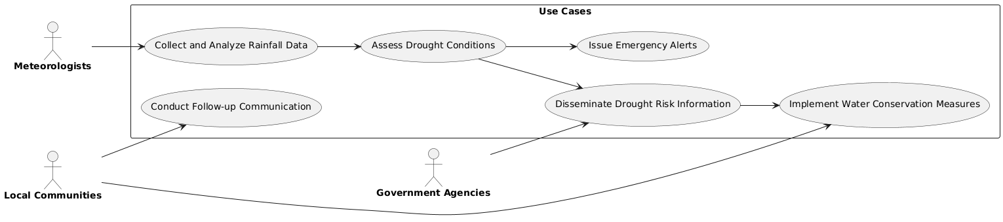

**Code For Figure 001_Intro_USecase_PlantUML**

@startuml

left to right direction

actor "**Meteorologists**" as meteorologists

actor "**Government Agencies**" as governmentAgencies

actor "**Local Communities**" as localCommunities

rectangle "<b>Use Cases</b>" {

usecase "Collect and Analyze Rainfall Data" as UC1

usecase "Assess Drought Conditions" as UC2

usecase "Disseminate Drought Risk Information" as UC3

usecase "Implement Water Conservation Measures" as UC4

usecase "Issue Emergency Alerts" as UC5

usecase "Conduct Follow-up Communication" as UC6

}

meteorologists --> UC1

UC1 --> UC2

governmentAgencies --> UC3

localCommunities --> UC4

UC2 --> UC3

UC3 --> UC4

UC2 --> UC5

localCommunities --> UC6

@enduml

**Figure 001_Intro_Usecase_MermaidJS**

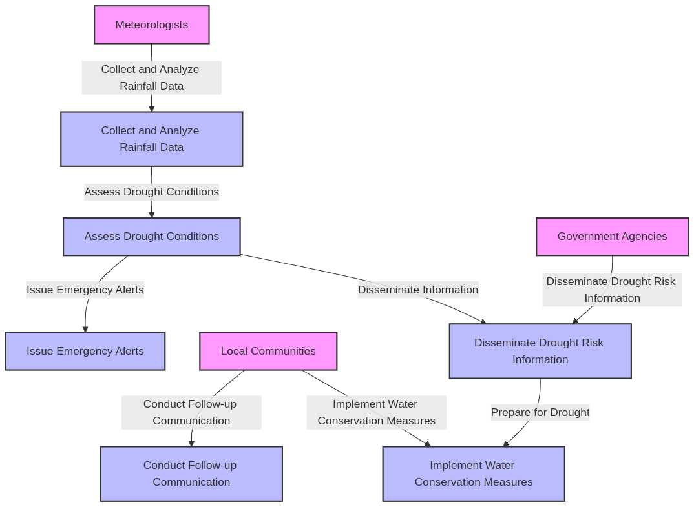

**Code for Figure 001_Intro_Usecase_MermaidJS**

%%{ init : { "theme" : "default" } }%%

graph TD

A[Meteorologists] -->|Collect and Analyze Rainfall Data| UC1[Collect and Analyze Rainfall Data]

UC1 -->|Assess Drought Conditions| UC2[Assess Drought Conditions]

B[Government Agencies] -->|Disseminate Drought Risk Information| UC3[Disseminate Drought Risk Information]

C[Local Communities] -->|Implmermaid-diagram-2025-03-04-105612ement Water Conservation Measures| UC4[Implement Water Conservation Measures]

UC2 -->|Disseminate Information| UC3

UC3 -->|Prepare for Drought| UC4

UC2 -->|Issue Emergency Alerts| UC5[Issue Emergency Alerts]

C -->|Conduct Follow-up Communication| UC6[Conduct Follow-up Communication]

style A fill:#f9f,stroke:#333,stroke-width:2px

style B fill:#f9f,stroke:#333,stroke-width:2px

style C fill:#f9f,stroke:#333,stroke-width:2px

style UC1 fill:#bbf,stroke:#333,stroke-width:2px

style UC2 fill:#bbf,stroke:#333,stroke-width:2px

style UC3 fill:#bbf,stroke:#333,stroke-width:2px

style UC4 fill:#bbf,stroke:#333,stroke-width:2px

style UC5 fill:#bbf,stroke:#333,stroke-width:2px

style UC6 fill:#bbf,stroke:#333,stroke-width:2px

**Figure 001_Intro_Usecase_NoteGPT**

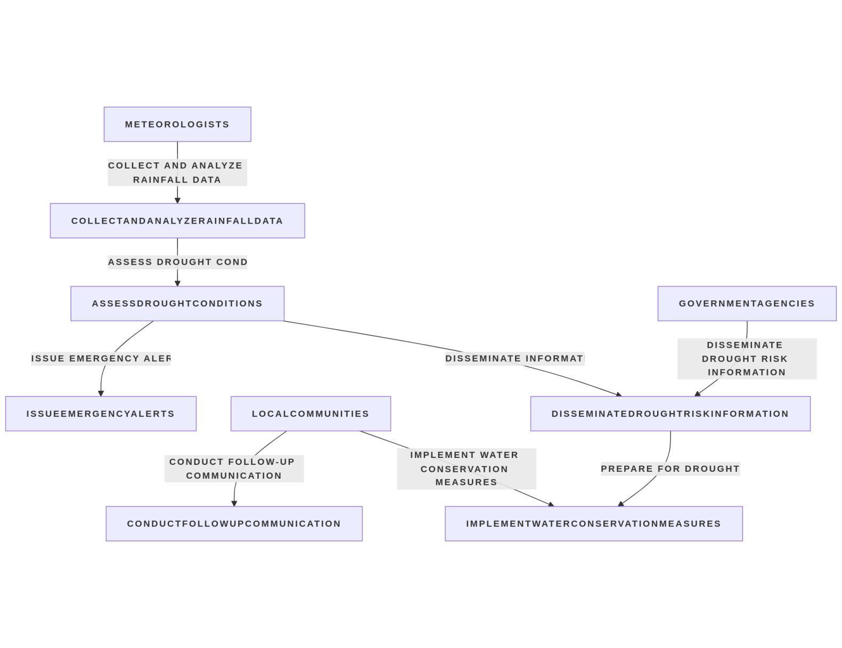

**Code for Figure 001_Intro_Usecase_NoteGPT**

%%{ init : { "theme" : "default" } }%%

graph TD

A[Meteorologists] -->|Collect and Analyze Rainfall Data| UC1[Collect and Analyze Rainfall Data]

UC1 -->|Assess Drought Conditions| UC2[Assess Drought Conditions]

B[Government Agencies] -->|Disseminate Drought Risk Information| UC3[Disseminate Drought Risk Information]

C[Local Communities] -->|Implement Water Conservation Measures| UC4[Implement Water Conservation Measures]

UC2 -->|Disseminate Information| UC3

UC3 -->|Prepare for Drought| UC4

UC2 -->|Issue Emergency Alerts| UC5[Issue Emergency Alerts]

C -->|Conduct Follow-up Communication| UC6[Conduct Follow-up Communication]

style A fill:#f9f,stroke:#333,stroke-width:2px

style B fill:#f9f,stroke:#333,stroke-width:2px

style C fill:#f9f,stroke:#333,stroke-width:2px

style UC1 fill:#bbf,stroke:#333,stroke-width:2px

style UC2 fill:#bbf,stroke:#333,stroke-width:2px

style UC3 fill:#bbf,stroke:#333,stroke-width:2px

style UC4 fi**Figure 002_enduser_Usecase_plantuml**ll:#bbf,stroke:#333,stroke-width:2px

style UC5 fill:#bbf,stroke:#333,stroke-width:2px

style UC6 fill:#bbf,stroke:#333,stroke-width:2px

**Used By (End Users):-** Researcher, Decision makers, administrators, academicians and public.

**Figure 002_enduser_Usecase_plantuml**

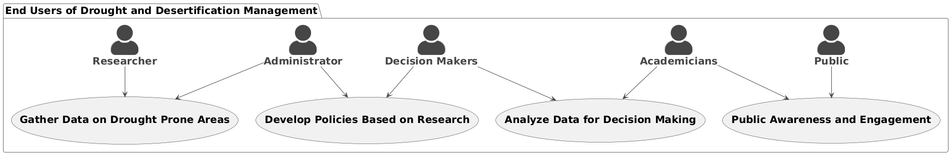

**code for Figure 002_enduser_Usecase_plantuml**

@startuml

!theme vibrant

skinparam actorstyle awesome

skinparam defaultfontsize 20

package "End Users of Drought and Desertification Management" {

actor Researcher as "**Researcher**"

actor Administrators as "**Administrator**"

actor DecisionMakers as "**Decision Makers**"

actor Academicians as "**Academicians**"

actor Public as "**Public**"

usecase "**Gather Data on Drought Prone Areas**" as UC1

usecase "**Analyze Data for Decision Making**" as UC2

usecase "**Develop Policies Based on Research**" as UC3

usecase "**Public Awareness and Engagement**" as UC4

Researcher --> UC1

Administrators --> UC1

DecisionMakers --> UC2

Academicians --> UC2

DecisionMakers --> UC3

Administrators --> UC3

Public --> UC4

Academicians --> UC4

}

@enduml

**Figure 002_enduser_Usecase_mermaidjs**

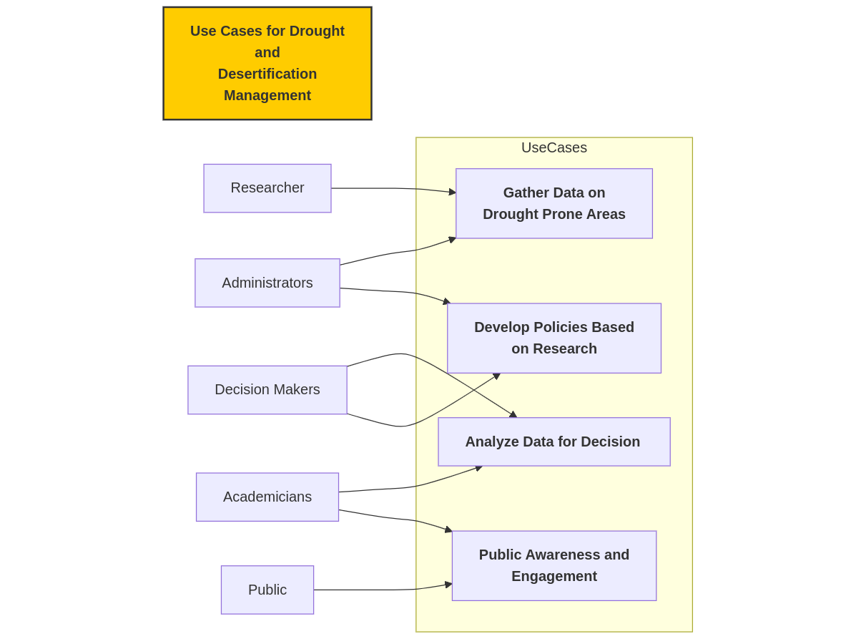

**code for Figure 002_enduser_Usecase_mermaidjs**

%%**{** init : **{**"theme" : "default"**}}**%%

**flowchart** LR

Title["Use Cases for Drought

and

Desertification Management"]**:::**titleStyle

**subgraph** UseCases

UC1[**Gather Data on

Drought Prone Areas**]

UC2[**Analyze Data for Decision Making**]

UC3[**Develop Policies Based

on Research**]

UC4[**Public Awareness and

Engagement**]

**end**

A[Researcher] **-->** UC1

B[Administrators] **-->** UC1

C[Decision Makers] **-->** UC2

D[Academicians] **-->** UC2

C **-->** UC3

B **-->** UC3

E[Public] **-->** UC4

D **-->** UC4

classDef titleStyle fill:#ffcc00,stroke:#333,stroke-width:2px,font-weight:bold**;**

class Title titleStyle

**Priority**:- **Medium Priority**

**Reframe:**

This classification indicates that the matter holds moderate importance and should be addressed promptly, although it is not as urgent as high-priority issues. Tasks or concerns designated as medium priority require attention and action but can be scheduled after more critical tasks have been completed. While this level of priority signifies that the issue is noteworthy, it does not present an immediate threat or necessitate urgent resolution. It is essential to monitor and manage medium-priority items to ensure they do not escalate into higher-priority concerns.

**Usecase of Priority:**

Actors:

* Project Manager
* Team Members
* Stakeholders

Description: This use case outlines the process of managing tasks classified as medium priority within a project or organizational context. It ensures that these tasks are addressed in a timely manner while prioritizing more critical issues.

Preconditions:

* A task management system is in place to categorize and prioritize tasks.
* Team members are trained to understand the priority classification system.

Main Flow:

1. Task Identification: The project manager identifies tasks that are classified as medium priority based on their importance and urgency.
2. Scheduling: The project manager schedules medium priority tasks to be addressed after high-priority tasks are completed.
3. Assignment: The project manager assigns medium priority tasks to appropriate team members, ensuring they understand the importance of these tasks.
4. Monitoring: Team members work on their assigned tasks, and the project manager monitors progress to ensure timely completion.
5. Review: The project manager conducts regular reviews of medium priority tasks to assess their status and determine if any require escalation to high priority.
6. Completion: Once completed, the project manager verifies the quality of the work and updates the task management system.

Alternative Flow:

* If a medium priority task begins to show signs of becoming urgent, the project manager may escalate it to high priority and reassign resources accordingly.

Post conditions:

* Medium priority tasks are completed in a timely manner without compromising the attention given to high-priority tasks.
* The project manager maintains an updated overview of all tasks, ensuring that no medium priority items escalate into higher-priority concerns.

Benefits:

* Efficient management of resources by ensuring that medium priority tasks are addressed without delaying critical tasks.
* Enhanced team productivity and focus, as team members are clear on the importance and timing of their assignments.
* Reduced risk of medium priority tasks escalating into urgent issues, leading to smoother project execution.

**Summary:**

This classification signifies moderate importance, requiring prompt attention but not as urgently as high-priority issues. Medium priority tasks can be scheduled after critical tasks and, while noteworthy, do not pose an immediate threat. It is crucial to monitor these items to prevent them from escalating into higher-priority concerns.

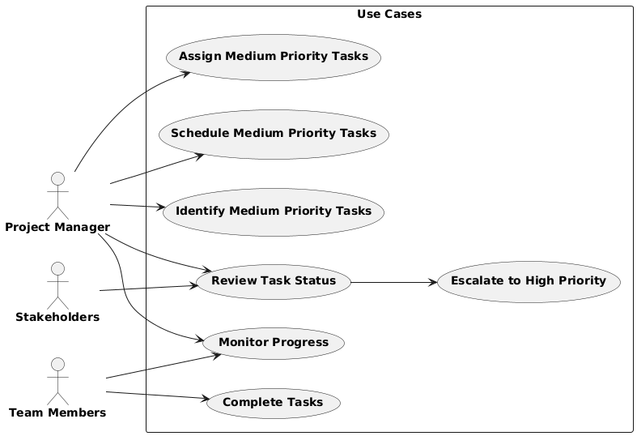**Figure 003_Priority_Usecase_PlantUML**

**Code For Figure 003_Priority_Usecase_PlantUML**

@startuml

left to right direction

actor "**Project Manager**" as PM

actor "**Team Members**" as TM

actor "**Stakeholders**" as SH

rectangle "<b>Use Cases</b>" {

usecase "<b>Identify Medium Priority Tasks</b>" as UC1

usecase "<b>Schedule Medium Priority Tasks</b>" as UC2

usecase "<b>Assign Medium Priority Tasks</b>" as UC3

usecase "<b>Monitor Progress</b>" as UC4

usecase "<b>Review Task Status</b>" as UC5

usecase "<b>Escalate to High Priority</b>" as UC6

usecase "<b>Complete Tasks</b>" as UC7

}

PM --> UC1

PM --> UC2

PM --> UC3

PM --> UC4

PM --> UC5

UC5 --> UC6

TM --> UC4

TM --> UC7

SH --> UC5

@enduml

**Figure 003_Priority_Usecase_PlantUML 2**

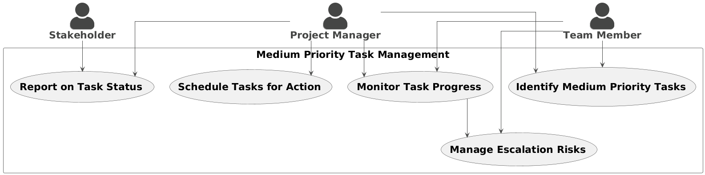**Code For Figure 003_Priority_Usecase_PlantUML 2**

@startuml

!theme vibrant

skinparam actorstyle awesome

skinparam defaultfontsize 22

skinparam linetype ortho

actor "**Project Manager**" as PM

actor "**Team Member**" as TM

actor "**Stakeholder**" as SH

rectangle "Medium Priority Task Management" {

usecase "**Identify Medium Priority Tasks**" as UC1

usecase "**Schedule Tasks for Action**" as UC2

usecase "**Monitor Task Progress**" as UC3

usecase "**Manage Escalation Risks**" as UC4

usecase "**Report on Task Status**" as UC5

}

PM --> UC1

PM --> UC2

PM --> UC3

PM --> UC5

TM --> UC1

TM --> UC3

TM --> UC4

SH --> UC5

UC3 --> UC4

@enduml

**Figure 003_Priority_Usecase_Mermaidjs**

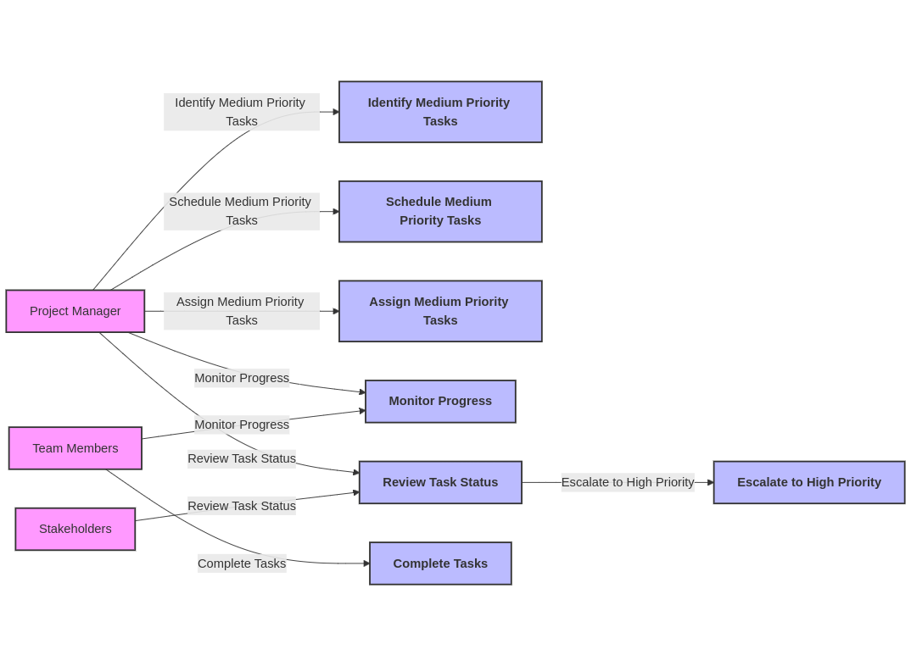**Code for Figure 003_Priority_Usecase_Mermaidjs**

%%**{** init : **{**"theme" : "default", "flowchart" : **{**"curve" : "linear"**}}}**%%

**flowchart** LR

A[Project Manager] **-->**|Identify Medium Priority Tasks| UC1[**Identify Medium Priority Tasks**]

A **-->**|Schedule Medium Priority Tasks| UC2[**Schedule Medium Priority Tasks**]

A **-->**|Assign Medium Priority Tasks| UC3[**Assign Medium Priority Tasks**]

A **-->**|Monitor Progress| UC4[**Monitor Progress**]

A **-->**|Review Task Status| UC5[**Review Task Status**]

UC5 **-->**|Escalate to High Priority| UC6[**Escalate to High Priority**]

B[Team Members] **-->**|Monitor Progress| UC4

B **-->**|Complete Tasks| UC7[**Complete Tasks**]

C[Stakeholders] **-->**|Review Task Status| UC5

style A fill:#f9f,stroke:#333,stroke-width:2px

style B fill:#f9f,stroke:#333,stroke-width:2px

style C fill:#f9f,stroke:#333,stroke-width:2px

style UC1 fill:#bbf,stroke:#333,stroke-width:2px

style UC2 fill:#bbf,stroke:#333,stroke-width:2px

style UC3 fill:#bbf,stroke:#333,stroke-width:2px

style UC4 fill:#bbf,stroke:#333,stroke-width:2px

style UC5 fill:#bbf,stroke:#333,stroke-width:2px

style UC6 fill:#bbf,stroke:#333,stroke-width:2px

style UC7 fill:#bbf,stroke:#333,stroke-width:2px

**Figure 003_Priority_Usecase_NOTEgpt**

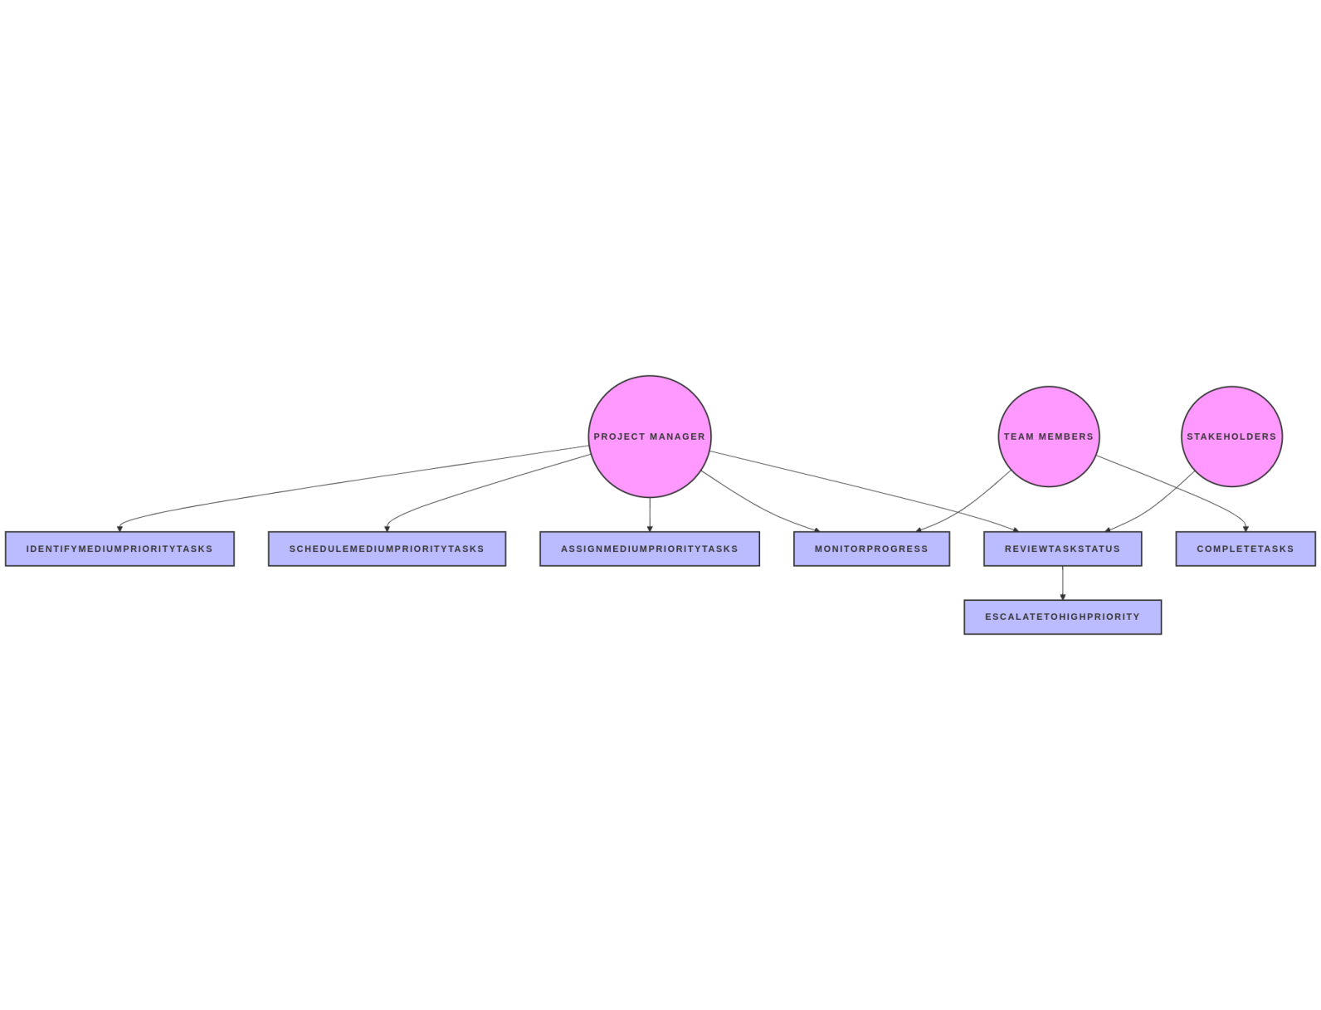

**Code for Figure 003_Priority_Usecase_NOTEgpt**

%%{ init : { "theme" : "default", "flowchart" : { "curve" : "linear" } } }%%

flowchart LR

A[Project Manager] -->|Identify Medium Priority Tasks| UC1[**Identify Medium Priority Tasks**]

A -->|Schedule Medium Priority Tasks| UC2[**Schedule Medium Priority Tasks**]

A -->|Assign Medium Priority Tasks| UC3[**Assign Medium Priority Tasks**]

A -->|Monitor Progress| UC4[**Monitor Progress**]

A -->|Review Task Status| UC5[**Review Task Status**]

UC5 -->|Escalate to High Priority| UC6[**Escalate to High Priority**]

B[Team Members] -->|Monitor Progress| UC4

B -->|Complete Tasks| UC7[**Complete Tasks**]

C[Stakeholders] -->|Review Task Status| UC5

style A fill:#f9f,stroke:#333,stroke-width:2px

style B fill:#f9f,stroke:#333,stroke-width:2px

style C fill:#f9f,stroke:#333,stroke-width:2px

style UC1 fill:#bbf,stroke:#333,stroke-width:2px

style UC2 fill:#bbf,stroke:#333,stroke-width:2px

style UC3 fill:#bbf,stroke:#333,stroke-width:2px

style UC4 fill:#bbf,stroke:#333,stroke-width:2px

style UC5 fill:#bbf,stroke:#333,stroke-width:2px

style UC6 fill:#bbf,stroke:#333,stroke-width:2px

style UC7 fill:#bbf,stroke:#333,stroke-width:2px

**Phase:-Subsumed: Phase 1**

**Governance Need (Business Problem):-**

**Issue**:-

1. Activities under DPAP /DDP are not spread over the entire length and breadth the problem areas, but are restricted to identified smaller areas, it would be logical to expect the impact of these programmes only over such limited areas. “The programmes have been implemented in a fragmented manner by different departments through rigid guidelines without any well designed plans prepared on watershed basis by involving the inhabitants. Except in a few places, in most of the cases the achievements have been dismal. Ecological degradation has been proceeding unabated in these areas with reduced forest cover, declining water table and a shortage of drinking water, fuel and fodder” (Hanumantha Rao Committee, 1994, Preface).
2. Watershed wise data on the performance evaluation is absence for these programmes.
3. Of the many factors responsible for the unsatisfactory performance of the Programmes, the most important one is that under both the programmes, a wide range of activities not necessarily related to the core objectives were taken up in the past by spreading them thinly over a widely dispersed area. This tended to defuse focus on efforts to be made for achieving the core objectives of the Programmes. The attempt at mitigating the sufferings of the people were aimed at the provision of adhoc relief through income generating activities funded from the area development programmes without integrating such works with programmes for land and water conservation.
4. There is no appropriate mufti-disciplinary agency at the district, block and the watershed level to prepare integrated plans which could be taken upfor implementation.

**Reframe:**

(I) The activities under the DPAP/DDP are not implemented across the entire range of problem areas but are instead confined to specific, smaller regions. Consequently, it is reasonable to anticipate that the impact of these programs will be limited to these designated areas. The implementation has been fragmented, carried out by various departments following rigid guidelines, without comprehensive watershed-based plans that involve local communities. As a result, achievements have been disappointing in most cases, with only a few exceptions. Ecological degradation continues unabated in these regions, characterized by diminishing forest cover, declining water tables, and shortages of drinking water, fuel, and fodder (Hanumantha Rao Committee, 1994, Preface).

(II) There is a lack of watershed-specific data for evaluating the performance of these programs.

(III) Among the various factors contributing to the unsatisfactory performance of the programs, a significant issue is that a wide array of activities, not directly aligned with the core objectives, has been undertaken in the past. These activities have been spread thinly over a broad area, which has diluted the focus on achieving the primary goals of the programs. Efforts to alleviate the hardships faced by the population have primarily involved providing ad hoc relief through income-generating activities funded by area development programs, without integrating these efforts with land and water conservation initiatives.

(IV) There is no suitable multi-disciplinary agency at the district, block, or watershed level to develop integrated plans for implementation.

**Usecase of Govt.Need:**

Actors**: Multi-disciplinary Agency**

* Main Flow:
  1. Gather data on local conditions and community needs.
  2. Involve local inhabitants in the planning process.
  3. Create comprehensive watershed-based plans.
  4. Review and finalize the plans for implementation.
* Alternative Flow:
  1. If community involvement is low, additional outreach efforts are initiated.
* Benefits: Ensures plans are relevant and supported by the community, leading to better outcomes.
* Preconditions: Availability of data on local conditions and community involvement.
* Postconditions: Integrated plans are developed and ready for implementation.

**Summary:**

The activities under the DPAP/DDP programs are limited to specific smaller areas rather than being spread across the entire problem regions, leading to a restricted impact. These programs have been implemented in a fragmented manner by various departments, following rigid guidelines without well-designed, watershed-based plans that involve local communities. Consequently, achievements have been largely disappointing, with ongoing ecological degradation characterized by reduced forest cover, declining water tables, and shortages of drinking water, fuel, and fodder. Additionally, there is a lack of watershed-specific data for performance evaluation. A significant factor in the programs' unsatisfactory performance is the inclusion of a wide range of activities not aligned with core objectives, which diluted focus and resulted in ad hoc relief efforts rather than integrated land and water conservation initiatives. Furthermore, there is no suitable multi-disciplinary agency at the district, block, or watershed level to develop and implement integrated plans.

**Figure 004_Govt.Need_Usecase_PlantUML**

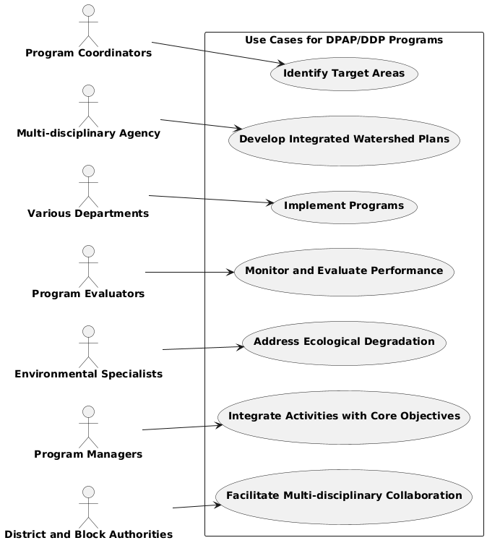

**Code for Fig 004_Govt.Need_Usecase_PlantUML**

@startuml

left to right direction

rectangle "<b>Use Cases for DPAP/DDP Programs</b>" {

usecase "<b>Identify Target Areas</b>" as UC1

usecase "<b>Develop Integrated Watershed Plans</b>" as UC2

usecase "<b>Implement Programs</b>" as UC3

usecase "<b>Monitor and Evaluate Performance</b>" as UC4

usecase "<b>Address Ecological Degradation</b>" as UC5

usecase "<b>Integrate Activities with Core Objectives</b>" as UC6

usecase "<b>Facilitate Multi-disciplinary Collaboration</b>" as UC7

}

actor "**Program Coordinators**" as A

actor "**Multi-disciplinary Agency**" as B

actor "**Various Departments**" as C

actor "**Program Evaluators**" as D

actor "**Environmental Specialists**" as E

actor "**Program Managers**" as F

actor "**District and Block Authorities**" as G

A --> UC1

B --> UC2

C --> UC3

D --> UC4

E --> UC5

F --> UC6

G --> UC7

@enduml

**Fig 004_Govt.Need_Usecase_PlantUML**

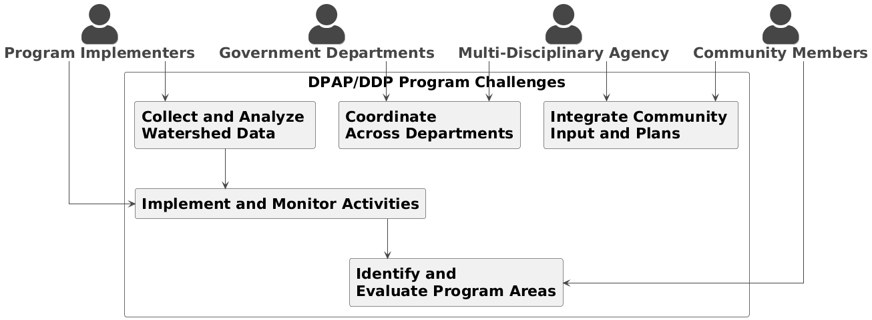

**Code For Fig 004_Govt.Need_Usecase_PlantUML**

@startuml

!theme vibrant

skinparam actorstyle awesome

skinparam defaultfontsize 22

skinparam linetype ortho

actor "**Community Members**" as CM

actor "**Program Implementers**" as PI

actor "**Multi-Disciplinary Agency**" as MDA

actor "**Government Departments**" as GD

rectangle "DPAP/DDP Program Challenges" {

rectangle "**Identify and** \n**Evaluate Program Areas**" as UC1

rectangle "**Integrate Community** \n**Input and Plans**" as UC2

rectangle "**Implement and Monitor Activities**" as UC3

rectangle "**Collect and Analyze** \n**Watershed Data**" as UC4

rectangle "**Coordinate** \n**Across Departments**" as UC5

}

CM --> UC1

CM --> UC2

PI --> UC3

PI --> UC4

MDA --> UC2

MDA --> UC5

GD --> UC5

UC3 --> UC1

UC4 --> UC3

@enduml

**Figure 004_Govt.Need_Usecase_mermaidjs**

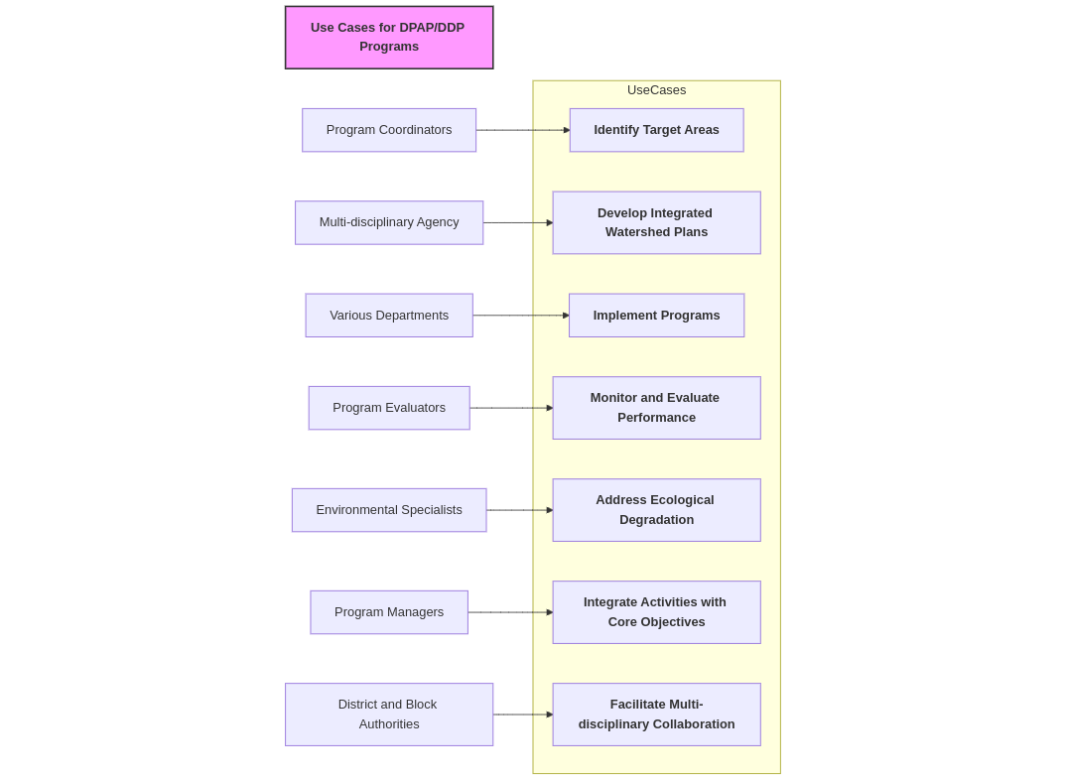**Code for 004_Govt.Need_Usecase_mermaidjs**

%%**{** init : **{**"theme" : "default"**}}**%%

**flowchart** LR

Title["Use Cases for DPAP/DDP Programs"]**:::**titleStyle

**subgraph** UseCases

UC1[**Identify Target Areas**]

UC2[**Develop Integrated Watershed Plans**]

UC3[**Implement Programs**]

UC4[**Monitor and Evaluate Performance**]

UC5[**Address Ecological Degradation**]

UC6[**Integrate Activities with Core Objectives**]

UC7[**Facilitate Multi-disciplinary Collaboration**]

**end**

A[Program Coordinators] **-->** UC1

B[Multi-disciplinary Agency] **-->** UC2

C[Various Departments] **-->** UC3

D[Program Evaluators] **-->** UC4

E[Environmental Specialists] **-->** UC5

F[Program Managers] **-->** UC6

G[District and Block Authorities] **-->** UC7

classDef titleStyle fill:#f9f,stroke:#333,stroke-width:2px,font-weight:bold**;**

class Title titleStyle

**Approach**:-

1. For overall success of any development programme, essential data which are crucial for watershed planning should be made available with the plate a sequence diagram code for this with bold text " (I) Areas under Drought Prone Development and Desertification Development –The information shows the area in sq. km, which is identified under DDP, or DPFAP programme in each block. (II) Tribal Sub-Plan Areas Of the Country –Tribal sub Plan Area (MoRD), Pockets Of Tribal Concentration & Predominantly tribal areas."nners at the district and block levels.
2. It is necessary to organise independent evaluation studies on a large scale and on a regular basis.
3. Through the active involvement of the people, these types of schemes will improve the environment and productivity of resources.
4. Updated data from concerning government agency (data of IWMP) is required to be incorporate to enhance the information covered under this module.

**Output:-**Showing The information on drought and desert prone areas at block level scale.

**Expected Outcome:-** The information on two main themes i.e.

1. Areas under Drought Prone Development and Desertification Development –The information shows the area in sq. km, which is identified under DDP, or DPFAP programme in each block.
2. Tribal Sub-Plan Areas Of the Country –Tribal sub Plan Area (MoRD), Pockets Of Tribal Concentration & Predominantly tribal areas.

**Figure 005_Expe.Outcome_Usecase__sequential_mermaidjs**

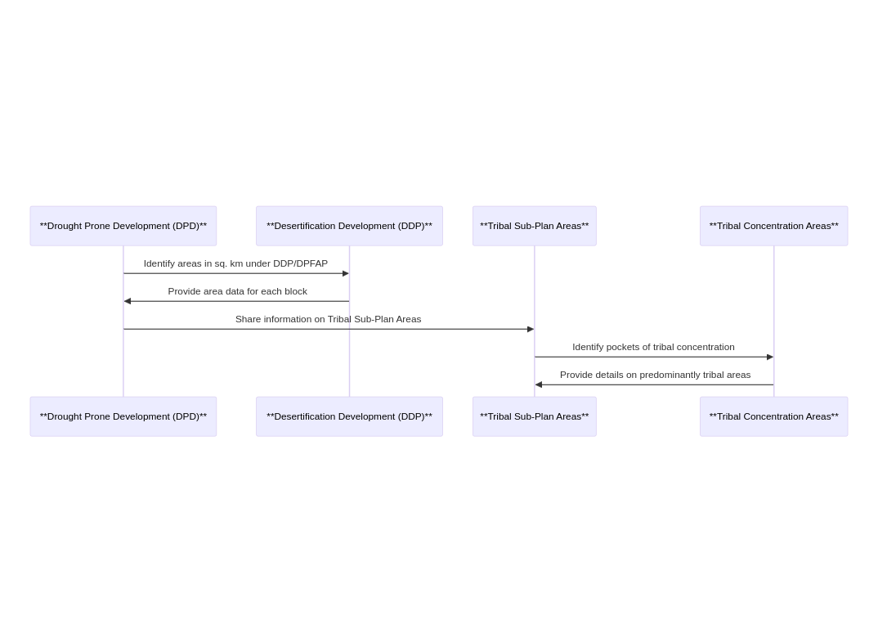

**Code for Figure 005_Expe.Outcome_Usecase__sequential_mermaidjs**

sequenceDiagram

participant A as **Drought Prone Development (DPD)**

participant B as **Desertification Development (DDP)**

participant C as **Tribal Sub-Plan Areas**

participant D as **Tribal Concentration Areas**

A->>B: Identify areas in sq. km under DDP/DPFAP

B->>A: Provide area data for each block

A->>C: Share information on Tribal Sub-Plan Areas

C->>D: Identify pockets of tribal concentration

D->>C: Provide details on predominantly tribal areas

**Visualization:-**

**A) Map at India Level** –

a) Drought Prone Development and Desertification Development data visualization -district/block wise.

**Figure 005_visualization_a__sequential_mermaidjs**

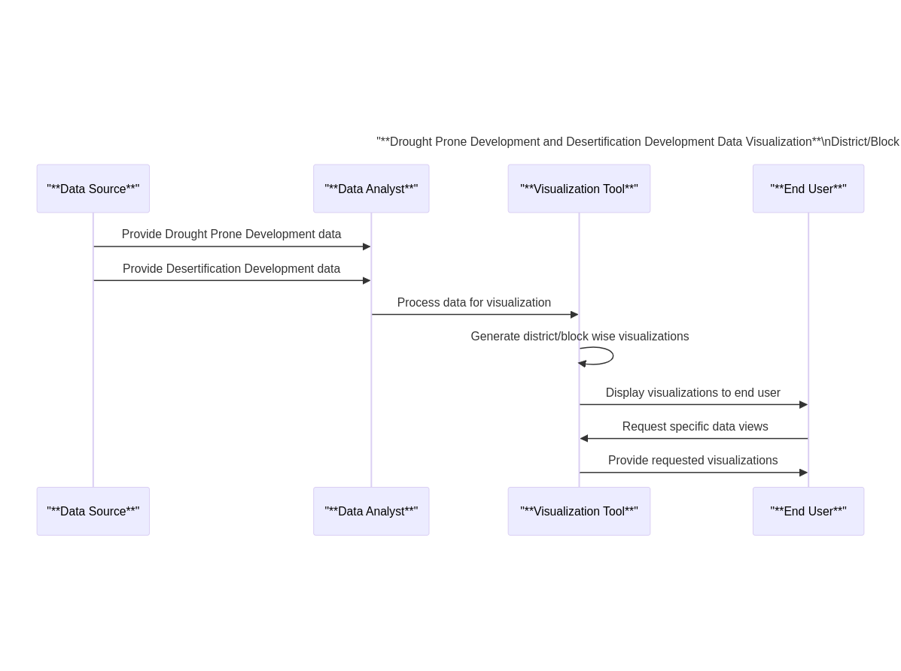**Code for Figure 005_visualization_a__sequential_mermaidjs**

**sequenceDiagram**

participant A as "**Data Source**"

participant B as "**Data Analyst**"

participant C as "**Visualization Tool**"

participant D as "**End User**"

title "**Drought Prone Development and Desertification Development Data Visualization**\nDistrict/Block Wise"

A**->>**B**:** Provide Drought Prone Development data

A**->>**B**:** Provide Desertification Development data

B**->>**C**:** Process data for visualization

C**->>**C**:** Generate district/block wise visualizations

C**->>**D**:** Display visualizations to end user

D**->>**C**:** Request specific data views

C**->>**D**:** Provide requested visualizations

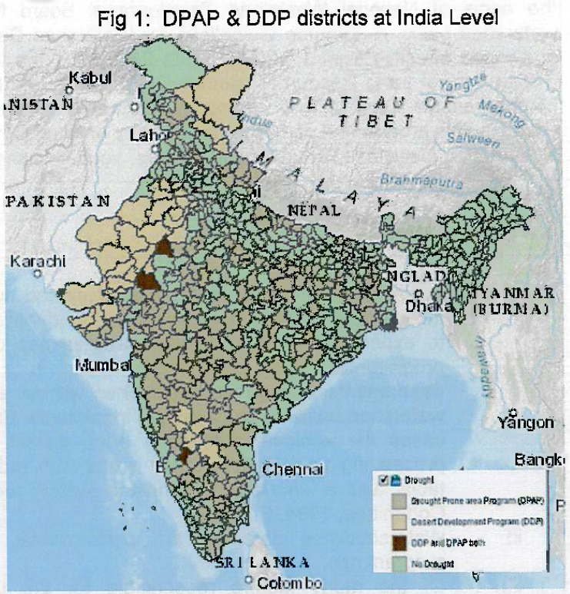

b) Tribal sub plan area details — district wise tribal sub plan area information, the state/UTs having pre moninant tribal population along with the pockets of tribal concentration areas of the country.

**Figure 006_visualization_b__sequential_mermaidjs**

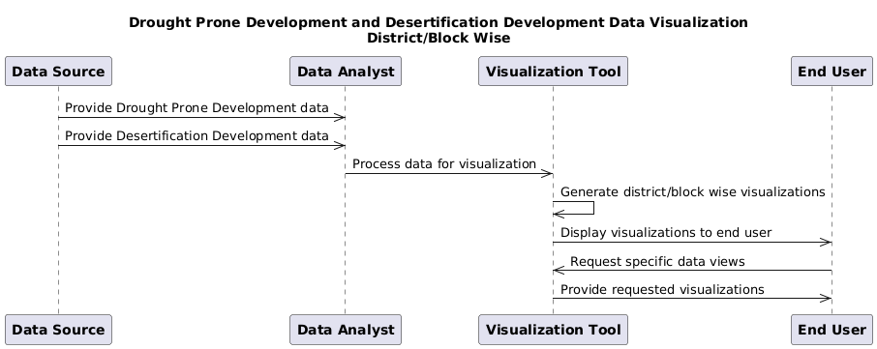

**Code for Figure 006_visualization_b__sequential_mermaidjs**

**sequenceDiagram**

@startuml

participant A as "**Data Source**"

participant B as "**Data Analyst**"

participant C as "**Visualization Tool**"

participant D as "**End User**"

title "**Drought Prone Development and Desertification Development Data Visualization**\nDistrict/Block Wise"

A->>B: Provide Drought Prone Development data

A->>B: Provide Desertification Development data

B->>C: Process data for visualization

C->>C: Generate district/block wise visualizations

C->>D: Display visualizations to end user

D->>C: Request specific data views

C->>D: Provide requested visualizations

@enduml

**2. Area statistic of drought data**

1. Area statistics administrative unit wise-state/district
2. Area statistics administrative unit wise-district/block.

**Figure 005_visualization_2__sequential_mermaidjs**

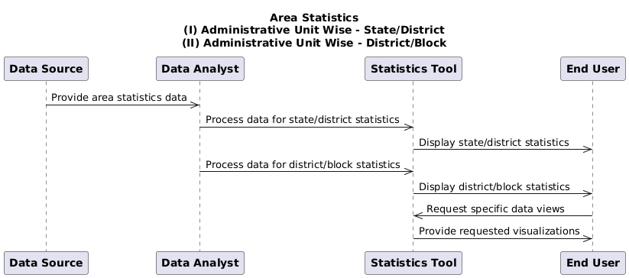

**Code for Figure 005_visualization_2__sequential_mermaidjs**

**sequenceDiagram**

@startuml

participant A as "**Data Source**"

participant B as "**Data Analyst**"

participant C as "**Statistics Tool**"

participant D as "**End User**"

title "**Area Statistics**\n(I) Administrative Unit Wise - State/District\n(II) Administrative Unit Wise - District/Block"

A->>B: Provide area statistics data

B->>C: Process data for state/district statistics

C->>D: Display state/district statistics

B->>C: Process data for district/block statistics

C->>D: Display district/block statistics

D->>C: Request specific data views

C->>D: Provide requested visualizations

@enduml

**3. Bar/Pie diagram - District wise and Basin wise chart option.**

**Figure 005_visualization_bar/pie_mermaidjs**

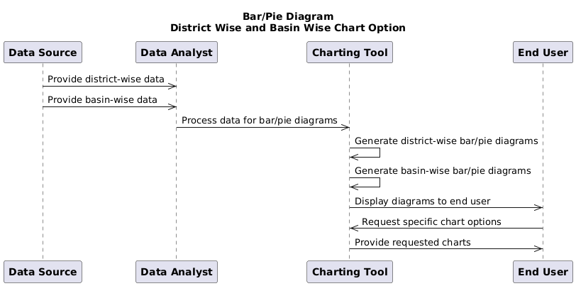

**Code for Figure 005_visualization_bar/pie__sequential_mermaidjs**

@startuml

participant A as "**Data Source**"

participant B as "**Data Analyst**"

participant C as "**Charting Tool**"

participant D as "**End User**"

title "**Bar/Pie Diagram**\nDistrict Wise and Basin Wise Chart Option"

A->>B: Provide district-wise data

A->>B: Provide basin-wise data

B->>C: Process data for bar/pie diagrams

C->>C: Generate district-wise bar/pie diagrams

C->>C: Generate basin-wise bar/pie diagrams

C->>D: Display diagrams to end user

D->>C: Request specific chart options

C->>D: Provide requested charts

**@enduml**

**4. DPAP Vs DDP block visualisation —district/block wise.**

**\*Selection/query and data visualization of the Desert Development Programme (DDP) & the Tribal Sub Plan Area MoRD will also be in the same way like that of the Drought Prone Areas Programme (DPAP) as shown above. All the information of DDP, DPAP & tribal sub plan areas of MoWR are entered into the respective layers as non spatial tables.\***

**Figure 005_visualization_DPAP__sequential_mermaidjs**

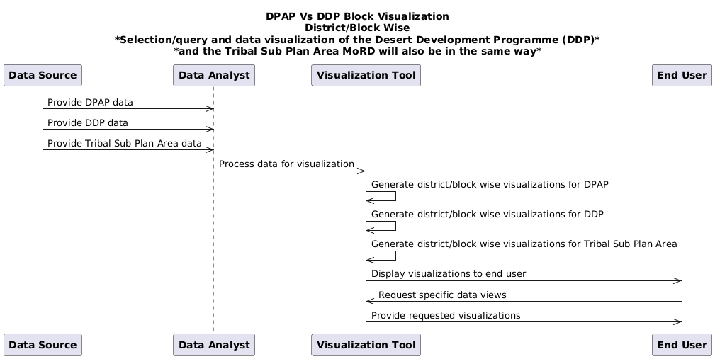

**Code for Figure 005_visualization_DPAP_sequential_mermaidjs**

**sequenceDiagram**

@startuml

participant A as "**Data Source**"

participant B as "**Data Analyst**"

participant C as "**Visualization Tool**"

participant D as "**End User**"

title "**DPAP Vs DDP Block Visualization**\nDistrict/Block Wise\n*Selection/query and data visualization of the Desert Development Programme (DDP)*\n*and the Tribal Sub Plan Area MoRD will also be in the same way*"

A->>B: Provide DPAP data

A->>B: Provide DDP data

A->>B: Provide Tribal Sub Plan Area data

B->>C: Process data for visualization

C->>C: Generate district/block wise visualizations for DPAP

C->>C: Generate district/block wise visualizations for DDP

C->>C: Generate district/block wise visualizations for Tribal Sub Plan Area

C->>D: Display visualizations to end user

D->>C: Request specific data views

C->>D: Provide requested visualizations

@enduml

**Frequency of Up-dation:-**As per data made available by Ministry of Rural Development.

**Measure of Success:-** The information on drought and desert prone areas in the country as declared by Ministry of Rural Development, Department of Land Resources, Govt. of India will be compiled under the module. User will get the information on the “earliest area development programme” launched by the Central Government in 1873-74 to tackle the special problems faced by those fragile areas which are constantly affected by severe drought conditions.

**Input Data Required:-**

**Geospatial Data:**

Frequency: One time published Data

(District/Blocks identified and published as drought prone area by MoRD and categorized under DPAP & DDP as well as tribal sub plan area information as per the MoRD.

Resolution : NA.

Extent of Coverage: Country level data

**Process:**

**Algorithm/Tools:-**

The integration of the DPAP, DDP and Tribal sub plan area data in to the Drought Affected Areas (2002) module will require following steps-

**Step 1:** For the declared districts/blocks under DDF/DPAP schemes & Tribal sub plan area, the administrative block, district and state boundaries will be used.

**Step 2:** Information will be entered as non- spatial tables of the vector data.

**Step 3:** GIS schema preparation, attribute finalization, data standardization, relationship establishment among different features.

**Step 4:** Preparation of map document of drought data layers with proper label, legends, scale and suitable visibility of layers at varying scales.

**Step 5:** Hosting GIS layers in the Drought Affected Areas Module. Documentation of the data visualization in the website. Spatial vector data will be accessed through QGIS server at production site.

**Step 6:** Development of GIS tools for query based on the user defined inputs.

**Figure 006_algoritham_sequential_mermaidjs**

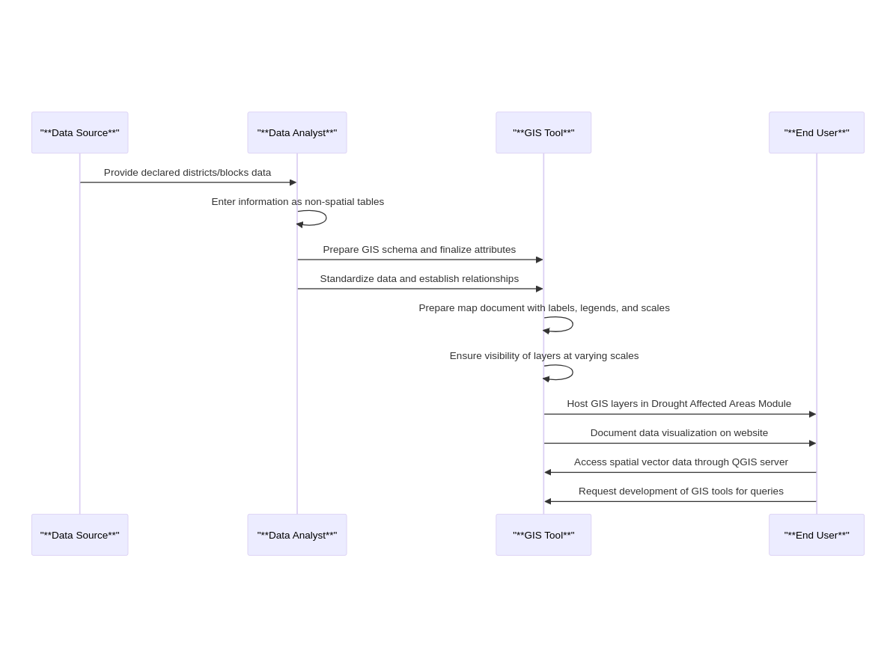

**Code Figure 006_algoritham_sequential_mermaidjs**

**sequenceDiagram**

participant A as "**Data Source**"

participant B as "**Data Analyst**"

participant C as "**GIS Tool**"

participant D as "**End User**"

A**->>**B**:** Provide declared districts/blocks data

B**->>**B**:** Enter information as non-spatial tables

B**->>**C**:** Prepare GIS schema and finalize attributes

B**->>**C**:** Standardize data and establish relationships

C**->>**C**:** Prepare map document with labels, legends, and scales

C**->>**C**:** Ensure visibility of layers at varying scales

C**->>**D**:** Host GIS layers in Drought Affected Areas Module

C**->>**D**:** Document data visualization on website

D**->>**C**:** Access spatial vector data through QGIS server

D**->>**C**:** Request development of GIS tools for queries

**Figure 006_Tools/Algo_SequDiag_PlantUML**

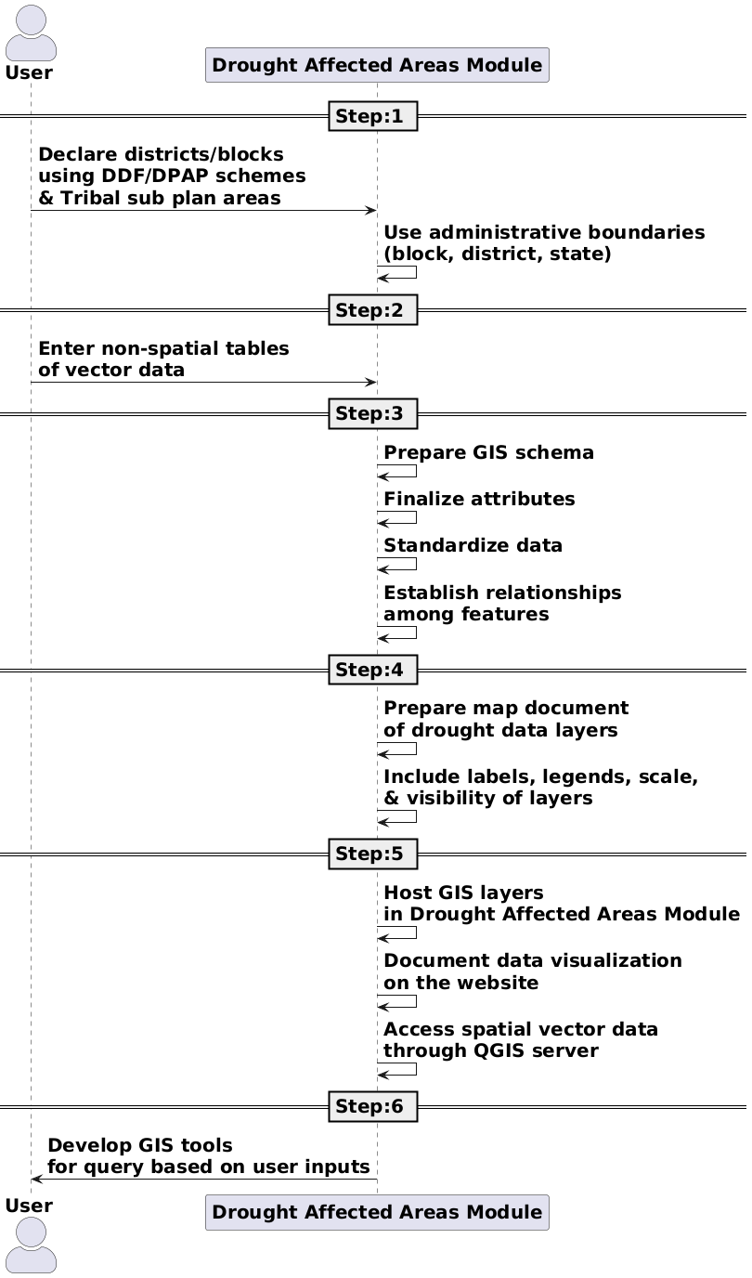

**Code For Figure 006_Tools/Algo_SequDiag_PlantUML**

@startuml

skinparam actorstyle awesome

skinparam defaultfontsize 20

actor "**User**" as user

participant "**Drought Affected Areas Module**" as module

== Step:1 ==

user -> module: **Declare districts/blocks**\n**using DDF/DPAP schemes**\n**& Tribal sub plan areas**

module -> module: **Use administrative boundaries**\n**(block, district, state)**

== Step:2 ==

user -> module: **Enter non-spatial tables**\n**of vector data**

== Step:3 ==

module -> module: **Prepare GIS schema**

module -> module: **Finalize attributes**

module -> module: **Standardize data**

module -> module: **Establish relationships**\n**among features**

== Step:4 ==

module -> module: **Prepare map document**\n**of drought data layers**

module -> module: **Include labels, legends, scale,**\n**& visibility of layers**

== Step:5 ==

module -> module: **Host GIS layers**\n**in Drought Affected Areas Module**

module -> module: **Document data visualization**\n**on the website**

module -> module: **Access spatial vector data**\n**through QGIS server**

== Step:6 ==

module -> user: **Develop GIS tools**\n**for query based on user inputs**

@enduml

**Data Validation:-**GIS data schema checking, relationship validation as well as attribute checking. Need proper

validation process before dissemination of data into the public domain.

**Software Technologies:-**  QGIS Desktop/ QGIS Enterprise

**Dependencies & Risks:** Data availability from concerned agencies. Data manipulation & data vetting.

**User Acceptance Testing (UAT):-** NWIC

**Development Responsibility:** NWIC

**References :-**

1. Report on the working group of sub-committee of the National Development Council (NDC) on dryland/rainfed farming system including regeneration of degraded/wasteland, watershed development programme.
2. Report of the. Technical Committee on. Drought Prone Areas. Programme and Desert Development Programme.Ministry of Rural Development. April — 1994.
3. MANUAL FOR DROUGHT MANAGEMENT DECEMBER 2016 (Updated upto December 2020). Department of Agriculture and Farmers Welfare Ministry of Agriculture and Farmers Welfare Government of India New Delhi.
4. <https://indiawris.gov.in/wris/#/Drought>
5. <https://indiawris.gov.in/wris/#/Compendium->India WRIS Module Description and Data Assessment Report.

**---End of Document---**